Individual Project : Best Occasion

Kartik Velede

8672807

User Experience and User Interface – INFO8890

Douglas Hardie

March-30 -2020

April-14-2020

**Table of Contents**

My Company Scenario 3

MoSCoW Prioritization of Business Requirements 3

Content Strategy 5

Design Critique of Existing SharePoint Site 6

Wireframe 7

Annotations 7

Site Map 10

Task Flows 11

Paper Prototype for Task-Flow 14

Usability Testing 16

References 18

# My Company Scenario

Over the past 30 years Best Occasion is standing out has a best event planning company for their full service provided to the customers. For maintaining all the documents, the company is using SharePoint Site and facing some issue such as disorganized pages, finding the information is very hard. So, the company now decided to recreate the SharePoint site. I Have been assigned the learning and development company scenario for IT department .

# MoSCoW Prioritization of Business Requirements

**Functional Requirement:**

The first functional requirement for this subsite is to have a separate page in order to submit the request for the new equipment’s. (Could Have)

The second functional requirement for this subsite is to have ticketing application where user raise and track a ticket if something is not working in the company. The status of the issue should be displayed or notified to the employee at each transition . (Must have)

**Operational Requirement:**

The first operational requirement for this subsite is to have calendar with all the dates when maintenance is going to take place in company , so that employees will know the time when system will be down. (Must Have)

The second operational requirement for this subsite to have the advertising page to get the updates about the changes in the process. The process is being changed in order to fill the process the gap (Could Have)

**Technical Requirement:**

The first Technical requirement for this subsite is to have the very good internet connectivity, because the functional of the site works only if there is proper internet connection established. (Must Have)

The second technical requirement for this subsite is to have the workflow for handling the tickets which are raised by user for the issues they are facing this in in-turn reduces the amount of email requests. (Could Have)

**Transitional Requirement:**

The first transitional requirement for this subsite to have end user training , uploading the important documents ,running through the setups is required beforehand.(Could Have)

The second transitional requirement for this subsite all the documents which contains information about solving the issue should be kept in protected zone while upgrading to new version or process (Must Have)

**Usability Requirement:**

The first usability requirement for this subsite is there should be an undo option available to users so that they can go back to previous activity if any mistake is made.(Must Have)

The second usability requirement for this subsite is users should not get disturbed with unwanted pop-up items in the site. ( Could Have)

After reviewing all the requirements, I listed the following requirements as a must have; [Functional requirement 2], [Operational requirement 1],[Transitional Requirement 2],[Technical requirement 1],[Usability requirement 1]. These are requirements that must be included in the system otherwise it will not achieve the purpose of the project. In specific we must have functional requirement 2 because it helps users better access content

# Content Strategy

After reviewing the sub-site and the requirements I have developed the follow of content strategy .

In the site the content types are of different kinds some of them are videos, eBooks, audio, slideshows, documents, feedback forms, pdf’s, contacts ,webforms and hyperlinks

**Content Life Cycle**

We can explain the technical request form by the content life cycle which is as below

**Assessment:** The users can submit the technical request by the form provided. The forms submitted will be analyzed and evaluated

**Strategy:** Determines the topical ownership areas and it varies based on the employee who raised the ticket for the technical issue.

**Plan:** The communication is made easy because the ticket raised by the user is also available to person who is assigned to work on technical issues.

**Create:** This phase in the content life cycle is used to check the quality assurance if the technical request is made by the user

**Maintain:** In order to maintain and upgrade the technical portal periodic auditing and determines the targets to accomplish in order to match with upgrading world.

# Design Critique of Existing SharePoint Site

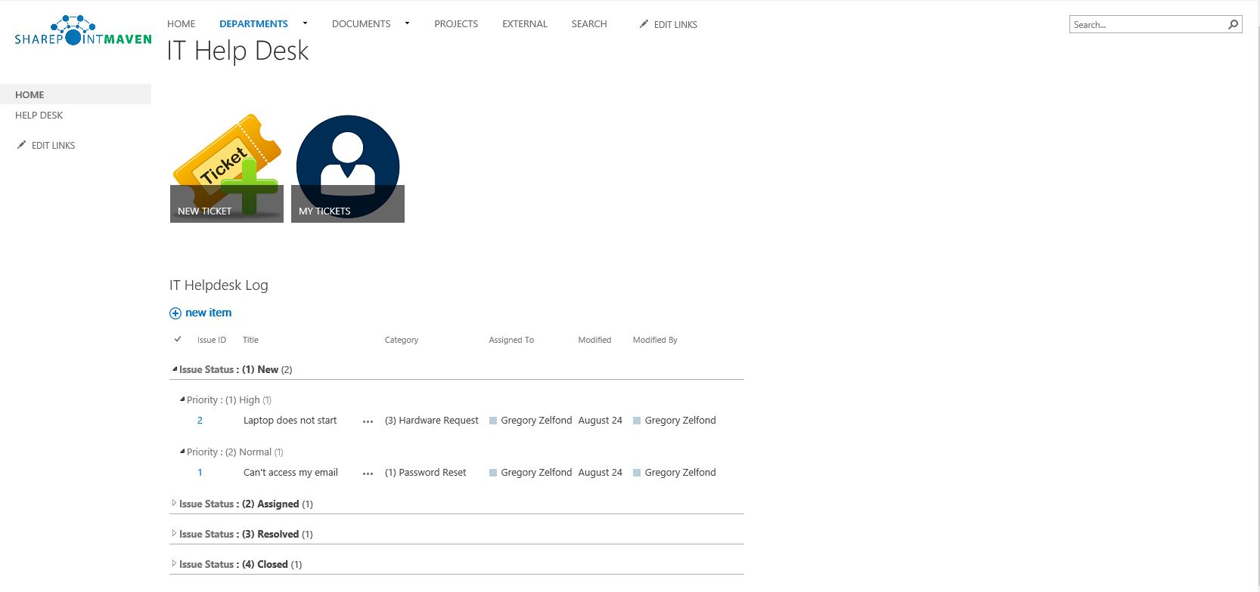

After reviewing the above existing SharePoint page, we can see there is a lot of room for improvement. There is some usage of whitespaces would change by adding the objects. There should be section which show any service outages. Maintenance calendar which show the employees when the system will be down is present no where in the site. There is no section in the page for the users to submit request for the new equipment which is must needed for the IT department. There is no policies section in the page which helps the employee to be aware about the company polices. By making these changes the site becomes more user-friendly for the employees within the organization.

**Visual Design Principles:**

1. The elements in the design are associated which each other via colour and position
2. The elements are arranged and presented in the order of their importance
3. My ticket and New ticket elements are given more visual weight so that elements will attract the eye
4. Some of the elements are kept close together to show their proximity.

# Wireframe

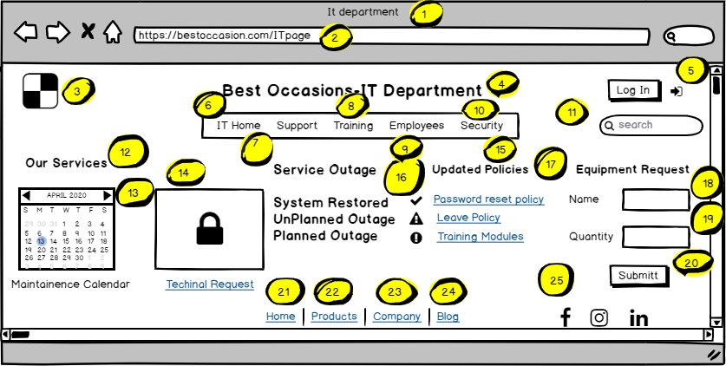

# Annotations

|  |  |  |  |  |
| --- | --- | --- | --- | --- |
| Footnote | Label | Description | Control Type | Content Type |
| 1 | Site Name | Name of the site department | Browser Window | Text |
| 2 | Site Path | A hyperlink path for the site | Browser Window | Text |
| 3 | Logo | Logo of the company | Icon | Visual |
| 4 | Title | This is the site title | Label | Text |
| 5 | Login | Allows the user to log in to page | Button | Text |
| 6 | IT Home | Redirects to home page of IT department where you can find several IT services provided | Link | Text |
| 7 | Support | Redirects to support team page where you can find the support for the issues your facing | Link | Text |
| 8 | Training | Redirects to Training page where you can again knowledge to resolve the issues by the training videos given | Link | Text |
| 9 | Employees | Redirects to employee’s page which contains the profile of all the employees in the company | Link | Text |
| 10 | Security | Redirects to security page to learn some basic security principles to followed while dealing with content | Link | Text |
| 11 | Search | A place to find content within site quickly and easily by typing the keyword | Input | Box |
| 12 | Our Services | Displays all the services that are provided by the IT department | Label | Text |
| 13 | Maintenance Calendar | To let the employees, know when the system will be slow so that they can the primitive actions before. | Image | Image |
| 14 | Technical Request | A place to raise the technical issues faced while working example: Log-out issues, network connectivity issues etc. | Link | Text |
| 15 | Updated  Policies | Displays the IT Policies of the company such as leave policy , HR policy , payment policy etc. | Link | Text |
| 16 | Service outage | A place to show any service outages in the system, network and software | Label | Text |
| 17 | Equipment Request | A place to request for the equipment needed like mouse , keyword, CPU ,sockets etc. | Label | Text |
| 18 | Name | Name of the equipment needed is mentioned here | Input | Text |
| 19 | Quantity | Number of units required for the particular equipment is mentioned | Input | Text |
| 20 | Submit | Once you click on submit button the request is directed to  Concern team about the need of equipment | Button | Text |
| 21 | Home | It is the hyperlink provided at the bottom of the page where you can go to home page of the company | Link | Text |
| 22 | Products | It is the hyperlink provided at the bottom of the page where you can go to product page of the company | Link | Text |
| 23 | Company | It is the hyperlink provided at the bottom of the page where you can go to companies main site from It department | Link | Text |
| 24 | Blog | Redirects to Blog page where you can find the basic information about the company | Link | Text |
| 25 | Social Tools | Helps to get to the social media page of the company where you can follow the page | Links | Visual |

# Site Map

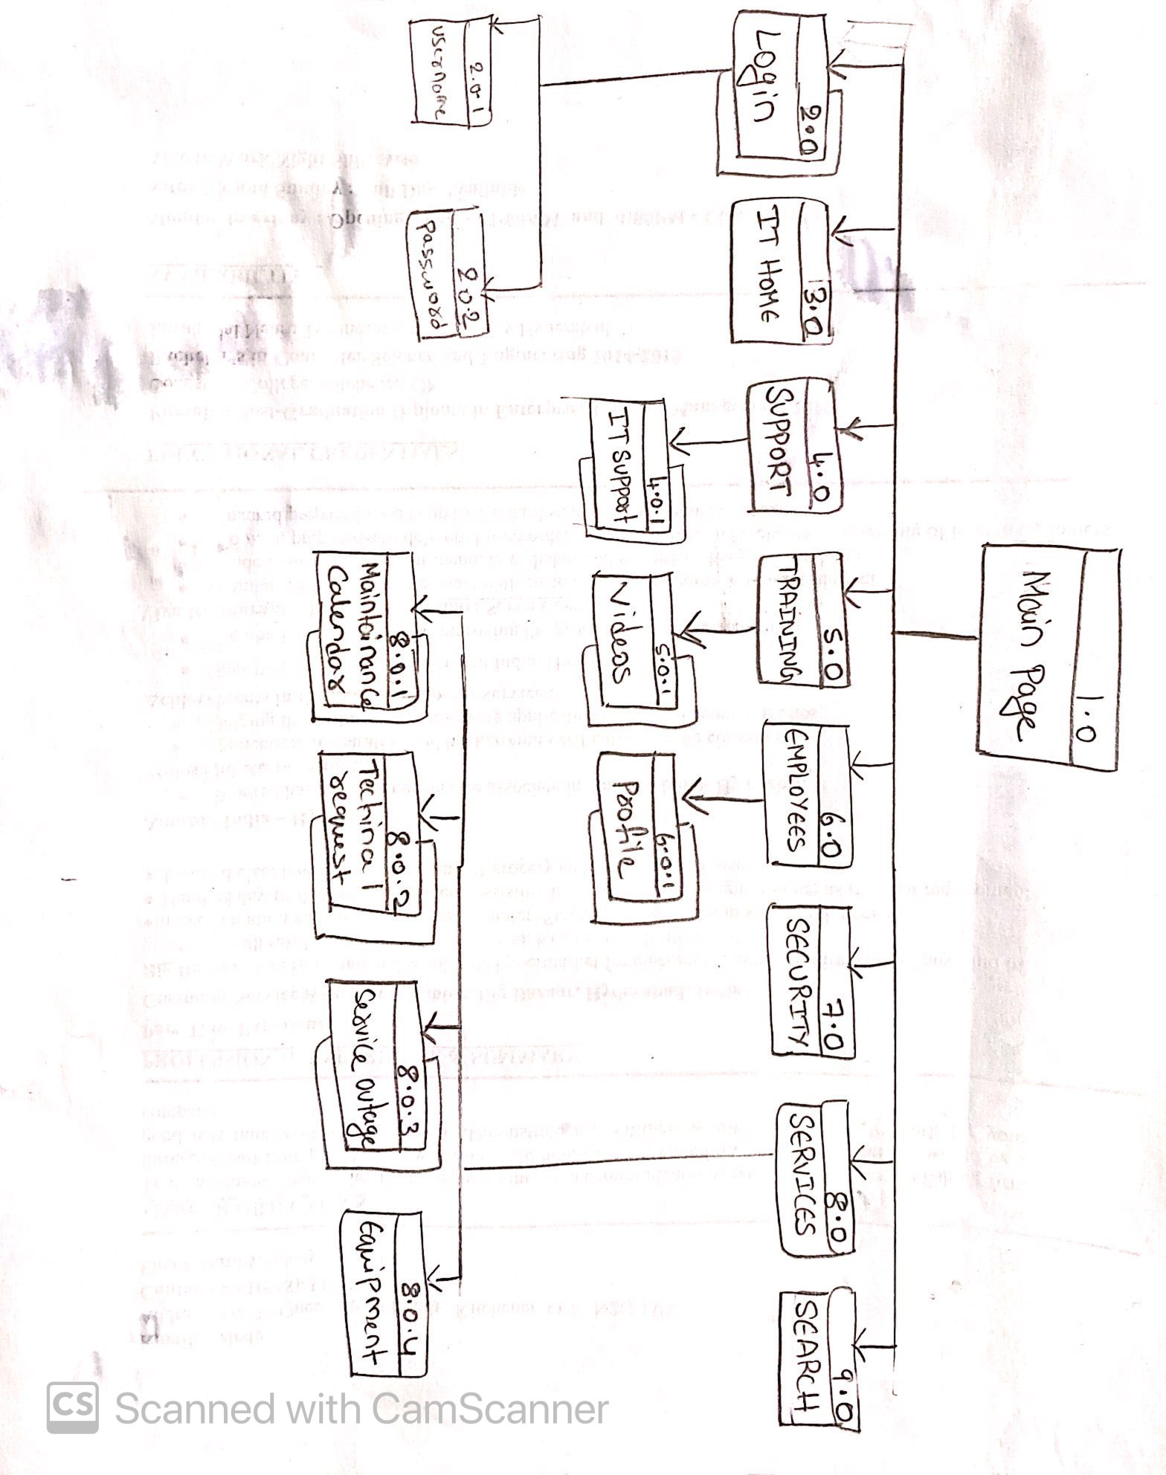

# Task Flows

1. Task-Flow for log in page 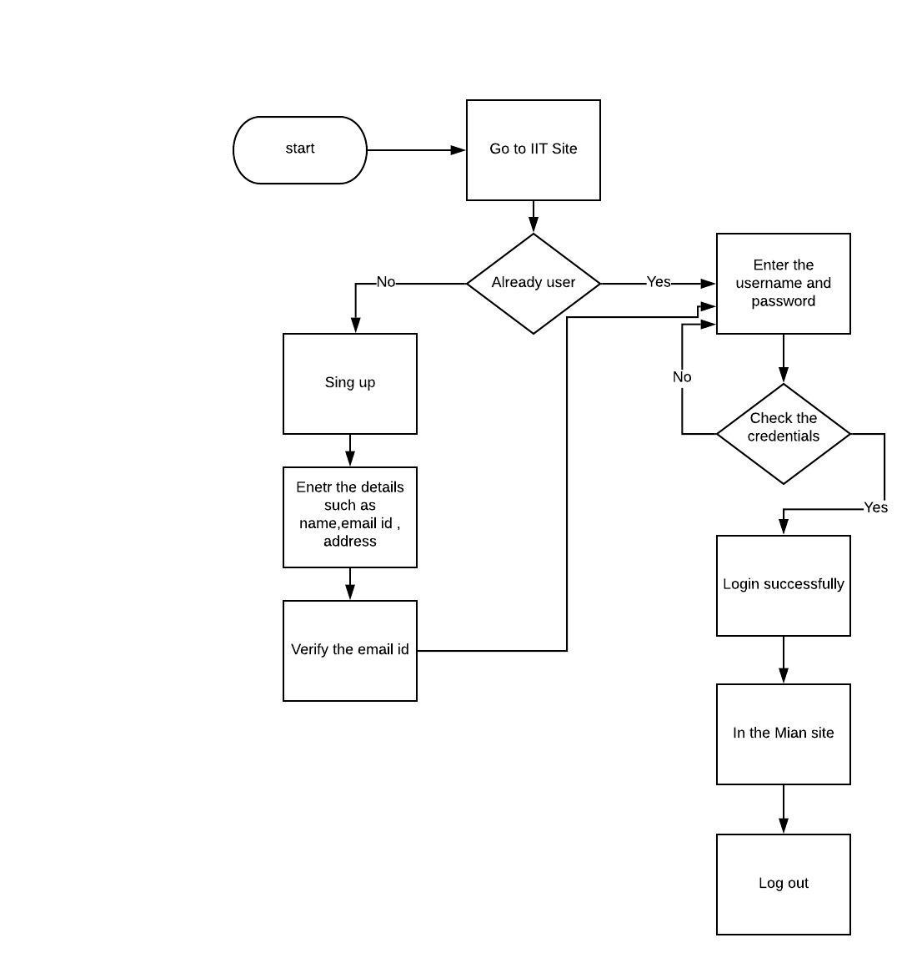
2. Task-Flow for equipment request

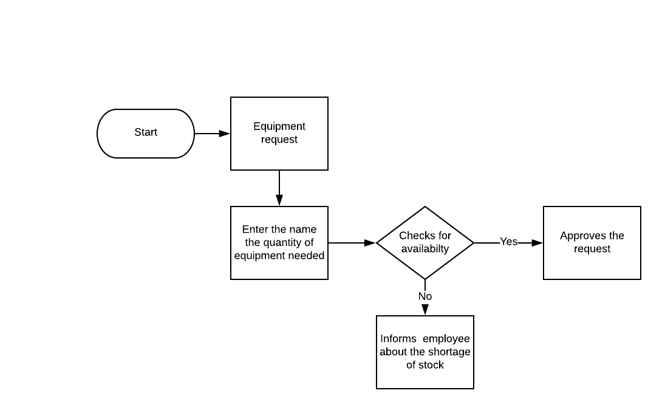

1. Task-Flow for Technical Request

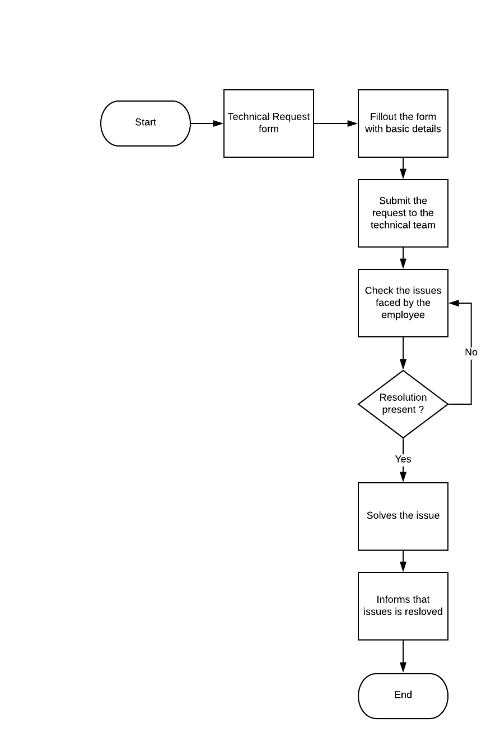

# Paper Prototype for Task-Flow

Paper Prototype for login task flow

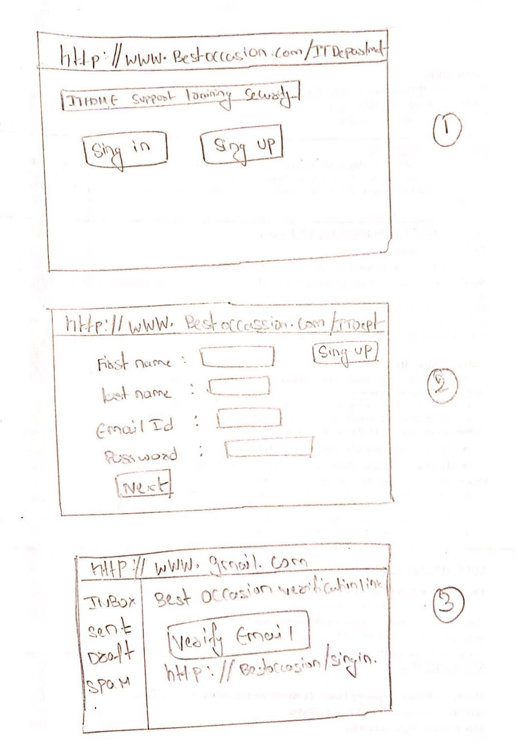

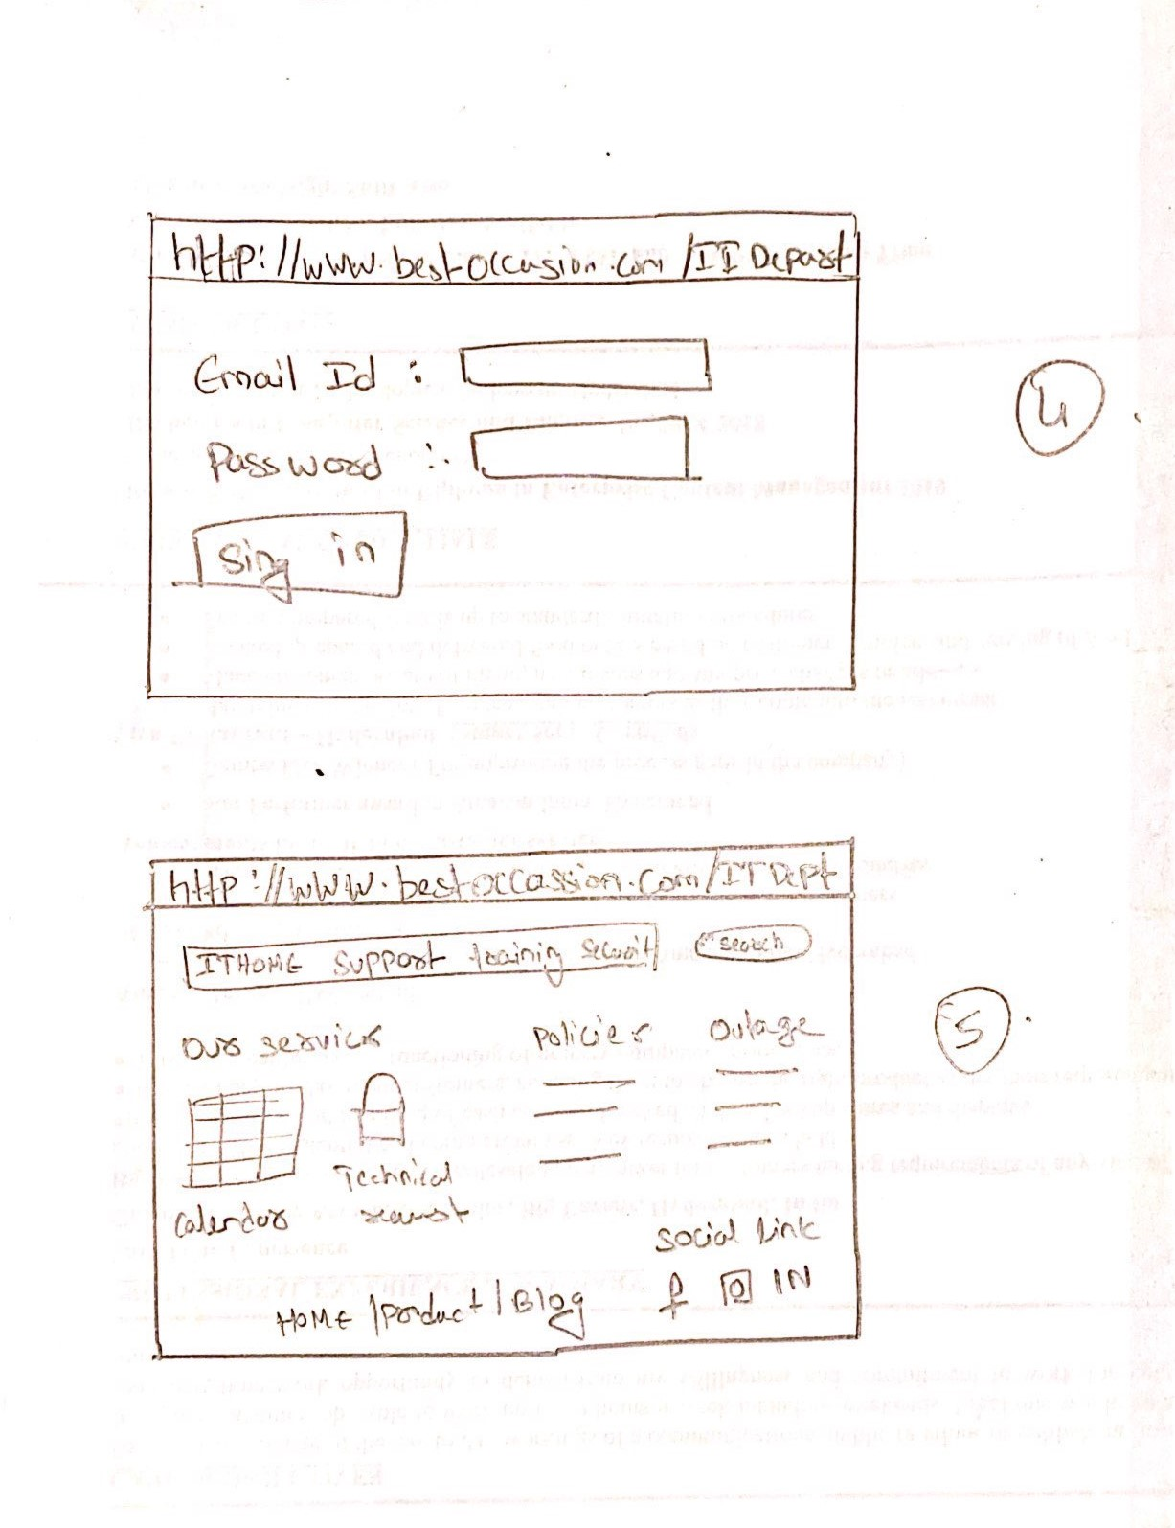

# Usability Testing

The site is being tested in the IT department main page of the Best Occasion Company

**Test Objectives:**

1. Sign up Process Testing : This is being tested in order to know if the user can login successfully or not
2. Equipment Request testing : Testing is done on equipment request portal to check if the user can submit the request of the equipment needed successfully or not
3. Technical Request Testing : Testing on technical request is done to ensure if the user can raise his/her issues successfully or not.
4. Testing the Policies portal : The policy section is tested to check whether if the user can see the updated polices in the department
5. Testing the Maintenance Calendar : Testing on calendar is done to check whether if the user can see the dates which system slow down may occur

**Location and date of test:**

Date : 13-04-2020

Time : 2:00 Am

Location : Best Occasion ,Toronto, Canada

**Participants:**

Five participants are selected in order to undergo the testing of site.

**Task 1:**

Akshay : Sign up process testing

Metrics : Sing up was successful

Log:

1. User clicks on the logon button
2. Enter the details which are asked and clicks on submit
3. User gets login into site successfully

**Task 2:**

Subodh: Equipment request testing

Metrics: The user was able to submit the request for equipment

Log:

1. User fills the details such as name of the equipment and quantity , then clicks on submit button
2. The pop up saying is request made is successfully is seen

**Task 3:**

Tarun: Technical request testing

Metrics: The user was able to make the technical request

Log:

1. User fill the technical form with issue he/she is facing
2. User received email notification from the technical team that the ticket has been received

**Task 4:**

Virat Kohli: Testing the policy portal

Metrics: The user was able to see all the policies in the company

Log:

1. User able to see the policy successfully by clicking on the link provided for policies

**Task 5:**

Siri : Testing the maintenance calendar

Metrics : The user was able to see the dates when the system is going is slow down

Log:

1. User can able to see all the marked down dates on the calendar about when the system will be down.

# References

Balsamiq. (2008). *balsamiq*. Retrieved April 13,2020, from [www.balsamiq.com](http://www.balsamiq.com/)

Gloo, H. (2001). *Gloo Maps*. Retrieved April 13,2020,from [www.gloomaps.com](http://www.gloomaps.com/)

Lucid Chart. (2000).*Lucid Chart*. Retrieved April 13,2020,from [www.lucidchart.com](http://www.lucidchart.com/)

Unger, R. (2002). *A Project guide to UX Design.* New Riders.